Vocabulary
Activities

- Vocabulary Development is the process whereby speakers of language enhance their vocabularies with new words.

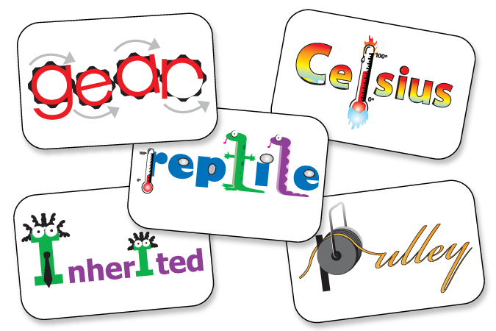

Activity: Synonym Guessing

Group Size: Small Group

Purpose: To develop knowledge of synonyms.

Materials: Word cards, paper, pencils.

Step by Step Directions:
- Divide small group into two teams. Ask one child from each team to sit in front of you. The rest of the team members will sit behind the two players.
- Hold up a word card. Do not show it to the two players.
- Choose a team to be first. Each team will except for their players in front of the teacher will see the word card.
- The members of the team chosen to play first will say a synonym for the word on the card. Then the student sitting in front of the teacher guesses the word.
- If the child does not guess correctly, the other team then gives a synonym to their player.
- The first player to identify the word earns a point for the team.
- A new student will then take the seat in front of the teacher for each team.

Activity: Definition Bingo

Group Size: Small or Large Group

Purpose: To develop knowledge of word meaning.

Materials: Bingo Cards, words children are learning or have learned, bingo markers.

Step by Step Directions:
- Distribute bingo cards.
- Write a group of words on the board that children are learning. Write more words than bingo squares. Tell children to use their best handwriting to write the word in each square. Ask children to mix up the words so that their card has words in squares different from their neighbors.
- Randomly select a word, give a simple definition. Children listen for definitions and cover the words that are defined.

Vocabulary Concept Maps

Group Size: Large/Small group, pairs, individual

Purpose: Develop word meaning.

Materials: Vocabulary concept map. (Web)

Step by Step Directions:
- Select an important word from the text that the children are reading. Write the word on the board.
- Discuss the words meanings. Refer to the text for examples of word use.
- Distribute the vocabulary concept maps. Children write the word in the center.
- Branching out from the map you may include these: Definition, Sentence from text using the word, student created sentence, picture.

Activity: Antonym/Synonym Concentration

Group Size: Pairs/Small Group

Purpose: To develop knowledge of synonyms or antonyms.

Materials: pairs of cards with antonyms or synonyms.

Step by Step Directions:
- Place cards face down in rows, or create an interactive concentration game on a white board. Children take turns turning up two cards.
- When a child turns up antonyms or synonyms, the child reads the words and keeps the cards.
- The child with the most cards, or matches wins.

Activity: Concept Wheels

Group Size: Small/Large Groups

Purpose: To develop and review word meanings.

Materials: White boards or paper.

Step by Step Directions:
- Find a key concept word from students’ readings. The students should be familiar with the word.
- Write the word on the board.
- The students will brainstorm everything they know about the word. Write their ideas on the board or paper.
- Draw a circle and divide it into four sections.
- The students will decide which four ideas represent to word the best.
- Write those four ideas in the sections.

Activity: Semantic Networks

Group Size: Small Group/Pairs

Purpose: To help children develop insight into the interconnectedness of concepts and ideas.

Materials: White board, pencils, paper

Step by Step Directions:
Before Reading:
- Write a word that labels an important concept and draw a circle around it. (Ex: water)
- Children brainstorm to think of everything they know about the concept. The teacher will write the words on the board.
During Reading
- Children will read the text and write down other words that describe or are related to the concept.
After Reading
- Add the words children wrote during reading to the board.
- The group discusses which words, ideas, and examples are relevant to the concept. Erase words that the group judges to be far afield from the concept.
- Have the group suggest ways to arrange the words. Draw bubbles around each and connect them with lines.

Activity: Definition Puzzles

Group Size: Large/Small Group, pairs, individual.

Purpose: To develop word meaning.

Materials: Definition puzzle.

Step by Step Directions:
- Chose words that students are learning in class.
- Write the definition or clue the word on the left hand column of the paper.
- Draw boxes to represent the number of letters in the word.
- The students will read the definition or clue and determine the word that will be written using the boxes.

Example:
* Definition: a person from whom you are descended
* Glue Your great grandfather would be considered this

a | n | c | e | s | t | o | r

Activity: Painting Synonyms

Group Size: Small Group/Individual

Purpose: To develop knowledge of synonyms

Materials: Paint sample strips with 5 shades, paper, pencils, pens

Step by Step Directions:
- Children will be given a word. (Ex: Love)
- Students will brainstorm words that are synonyms of that word.
- The student/s will decide which five words represent the word the best.
- They will order their words from their “okay” word to their “wow” word. The “okay” word will be written at the top shade of the paint strip followed by the next three in rank. The “wow” word will be written last.
- These can be kept and used while students are writing to vamp up commonly used or boring words.

